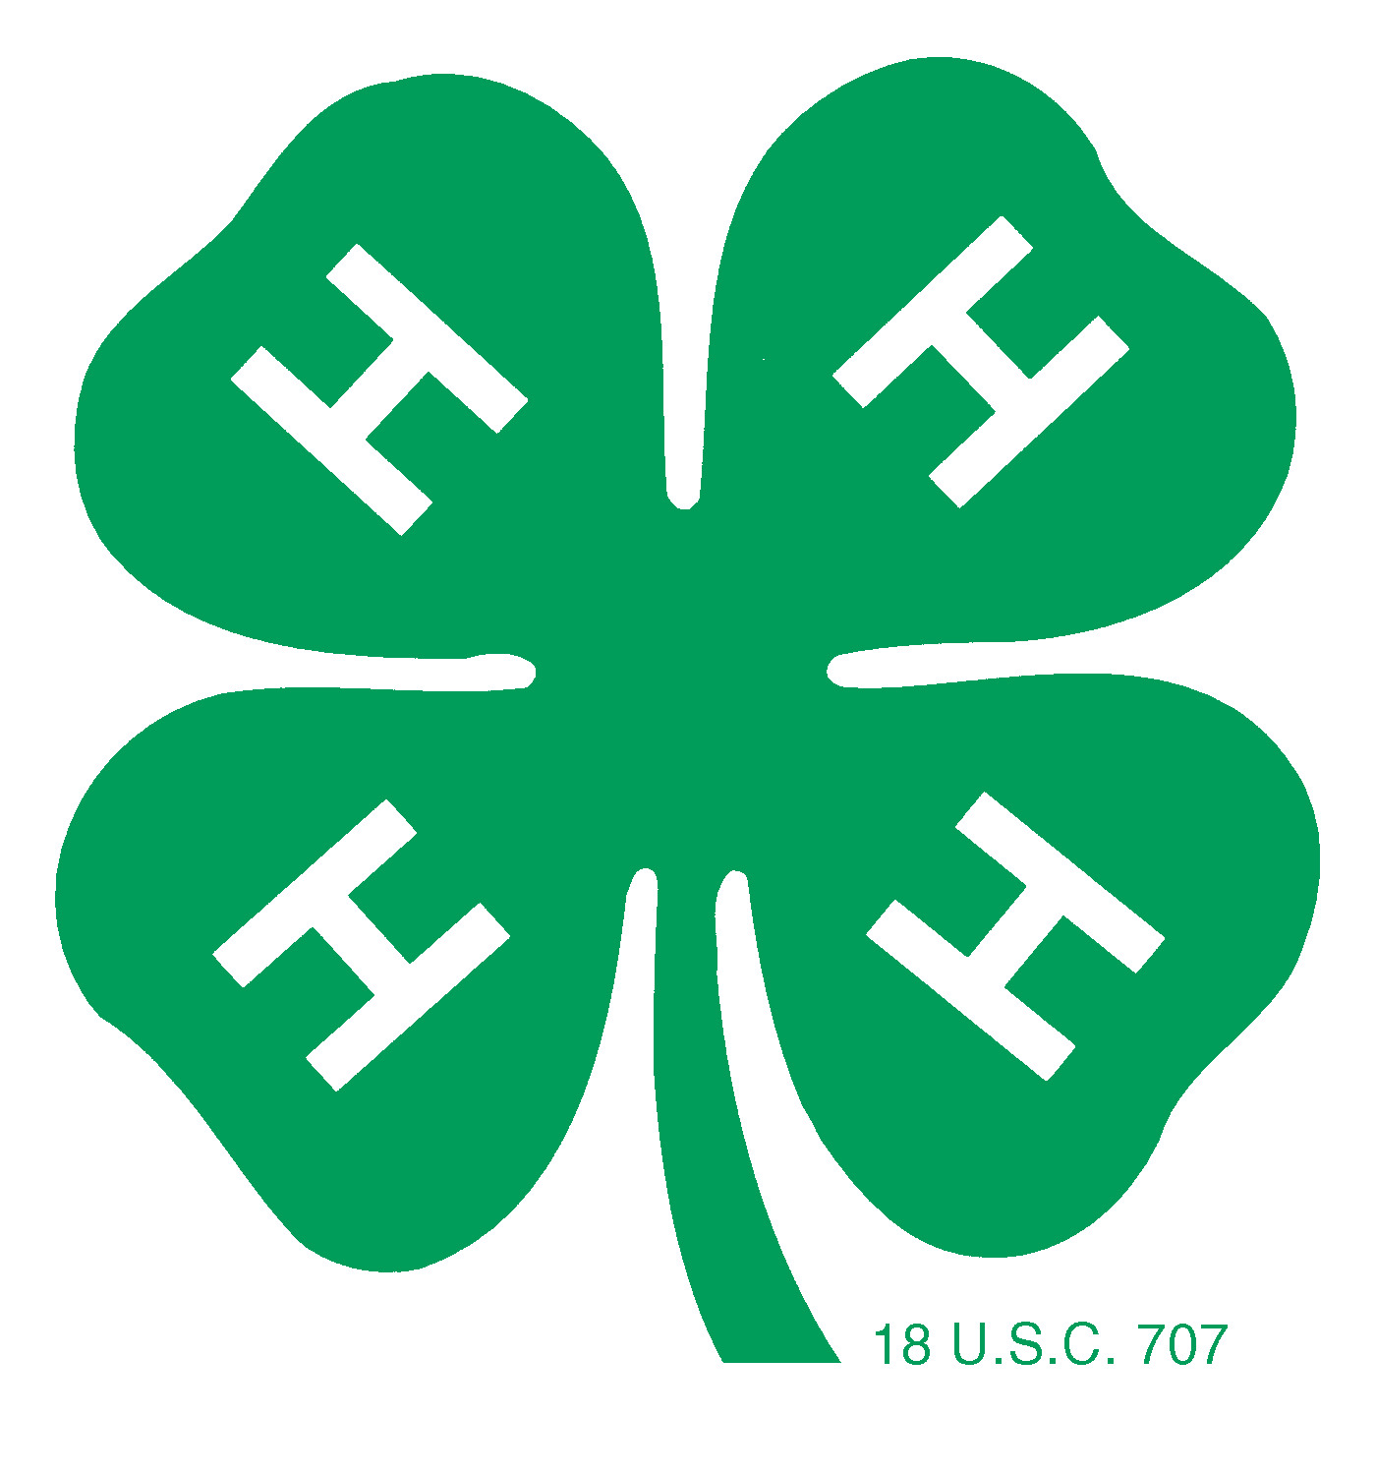 | National 4-H Healthy Living Youth Ambassador

Ambassador Application

Applicant Information
Full Name: |  |  |  | Date:
 | Last | First | M.I.

Address:
 | Street Address | Apartment/Unit #

 | City | State | ZIP Code

Phone: |  | Email

Education
High School: |  | Address:

From: |  | To: |  | Did you graduate? | YES | NO

College: |  | Address:

Year of School:
From: |  | To: |  | Did you graduate? | YES | NO | Degree:

Other: |  | Address:

From: |  | To: |  | Did you graduate? | YES | NO | Degree:

Healthy Living Category

What areas of Healthy Living are you passionate about (check all that apply)?

Bullying
Emotional
Environmental
Exercise/Physical Activity
Nutrition/ Healthy Eating
Poverty (action, prevention, etc.)
Social
Other

Hunger

If “Other”, please explain here:

Short Answer

Each response should answer the question fully and give a complete thought. There is no word limit so make your response an appropriate length to get your idea across. We want to see what makes you a strong leader, team player and creative thinker. Make sure to include your personality to give the selection committee an idea of who you are as a person. Please Note: Your short answers and supporting media must not exceed six pages. The full application including above cover page and signature page should not exceed eight pages (not including recommendation letters).

1. What category of Healthy Living (see list above) are you most passionate about and why?

2. What are your 2-3 most significant leadership experiences and what have you learned from them?

3. How would your participation benefit the 4-H Healthy Living Management Team as a whole? What unique skills/attributes do you bring to the table?

4. Describe a situation when you worked as part of a team of youth and adults to accomplish a goal.

5. Why do you want to be a 4-H Healthy Living Youth Ambassador?

Supporting Media

Please attach or send in any supporting media that you would like the selection committee to review. The types of media are open to anything that can be mailed in with this application or accessed on the internet. Some examples include: Newspaper clippings, videos, essays, pictures, PowerPoint or Prezi presentations, the options are limitless so be creative! These materials will be confidential only to the review committee. Do not send in any original materials, copies only. Anything you send in will not be returned.

Recommendation
Please obtain two letters of recommendation for your application. One letter should be from a 4-H agent, 4-H volunteer, or state 4-H program leader. The second letter should be from a non-4-H adult such as a teacher, principal, or employer. These letters should be one page. Recommendations can be e-mailed, mailed, or faxed directly by the recommender to: E-mail: emabry@fourhcouncil.edu (Subject: HL Youth Ambassador Application) Fax: 301-961-2894; Mailing address: Erika D. Mabry, National 4-H Council, 7100 Connecticut Avenue, Chevy Chase, MD 20815. All recommendations must be submitted by April 15, 2014.

Disclaimer and Signature
I certify that my answers are true and complete to the best of my knowledge.
If this application leads to selection, I understand that false or misleading information in my application or interview may result in my release.
Signature: |  | Date:

Signature of Parent/Legal Guardian if under age 18:_____________________________ Date ____________________

Submit your completed application no later than April 15, 2014 via:
- E-mail: emabry@fourhcouncil.edu (Subject: HL Youth Ambassador Application)
- Fax: 301-961-2894 or
- Mail: Erika D. Mabry, National 4-H Council, 7100 Connecticut Avenue, Chevy Chase, MD 20815

